**Overview**

* Many distinct Native American groups populated the southwest region of the current United States, starting in about 7000 BCE.
* The Ancestral Pueblos—the Anasazi, Mogollon, and Hohokam—began farming in the region as early as 2000 BCE, producing an abundance of corn. Navajos and Apaches primarily hunted and gathered in the area.
* These groups deserted the area around 1300 CE, probably due to crop failures; European colonists encountered people partially descended from the Ancestral Pueblos in the mid-1500s.

**Geographic and temporal setting: the Pueblo desert**

The Southwest region, expanding through present-day Arizona and New Mexico and into Colorado, Texas, Utah, and Mexico, was home to a variety of indigenous groups and cultural practices pre-colonization. In this region dwelled several groups we collectively call the Pueblo. The Spanish first gave them this name, which means “town” or “village,” because they lived in towns or villages of permanent stone-and-mud buildings with thatched roofs. The three main groups of the Pueblo people were the **Mogollon, Hohokam, and Anasazi**.

Anasazis, sometimes called the **Ancestral Pueblos**, resided in the Four Corners region (where the states of Colorado, Utah, New Mexico, and Arizona meet today); the Mogollon lived mostly in southwestern New Mexico; the Hohokam dominated the desert of southern Arizona.

Historians estimate that these three groups reigned over the region from approximately 200-1500 CE, and either dissolved or evolved into the Pueblos, whom the Spanish encountered during colonization and who still reside in modern **New Mexico**. They have also transformed into the Zuni and Hopi tribes. The Apache and Navajo tribes arrived in the Pueblo region around 1200 CE from the Pacific Northwest and 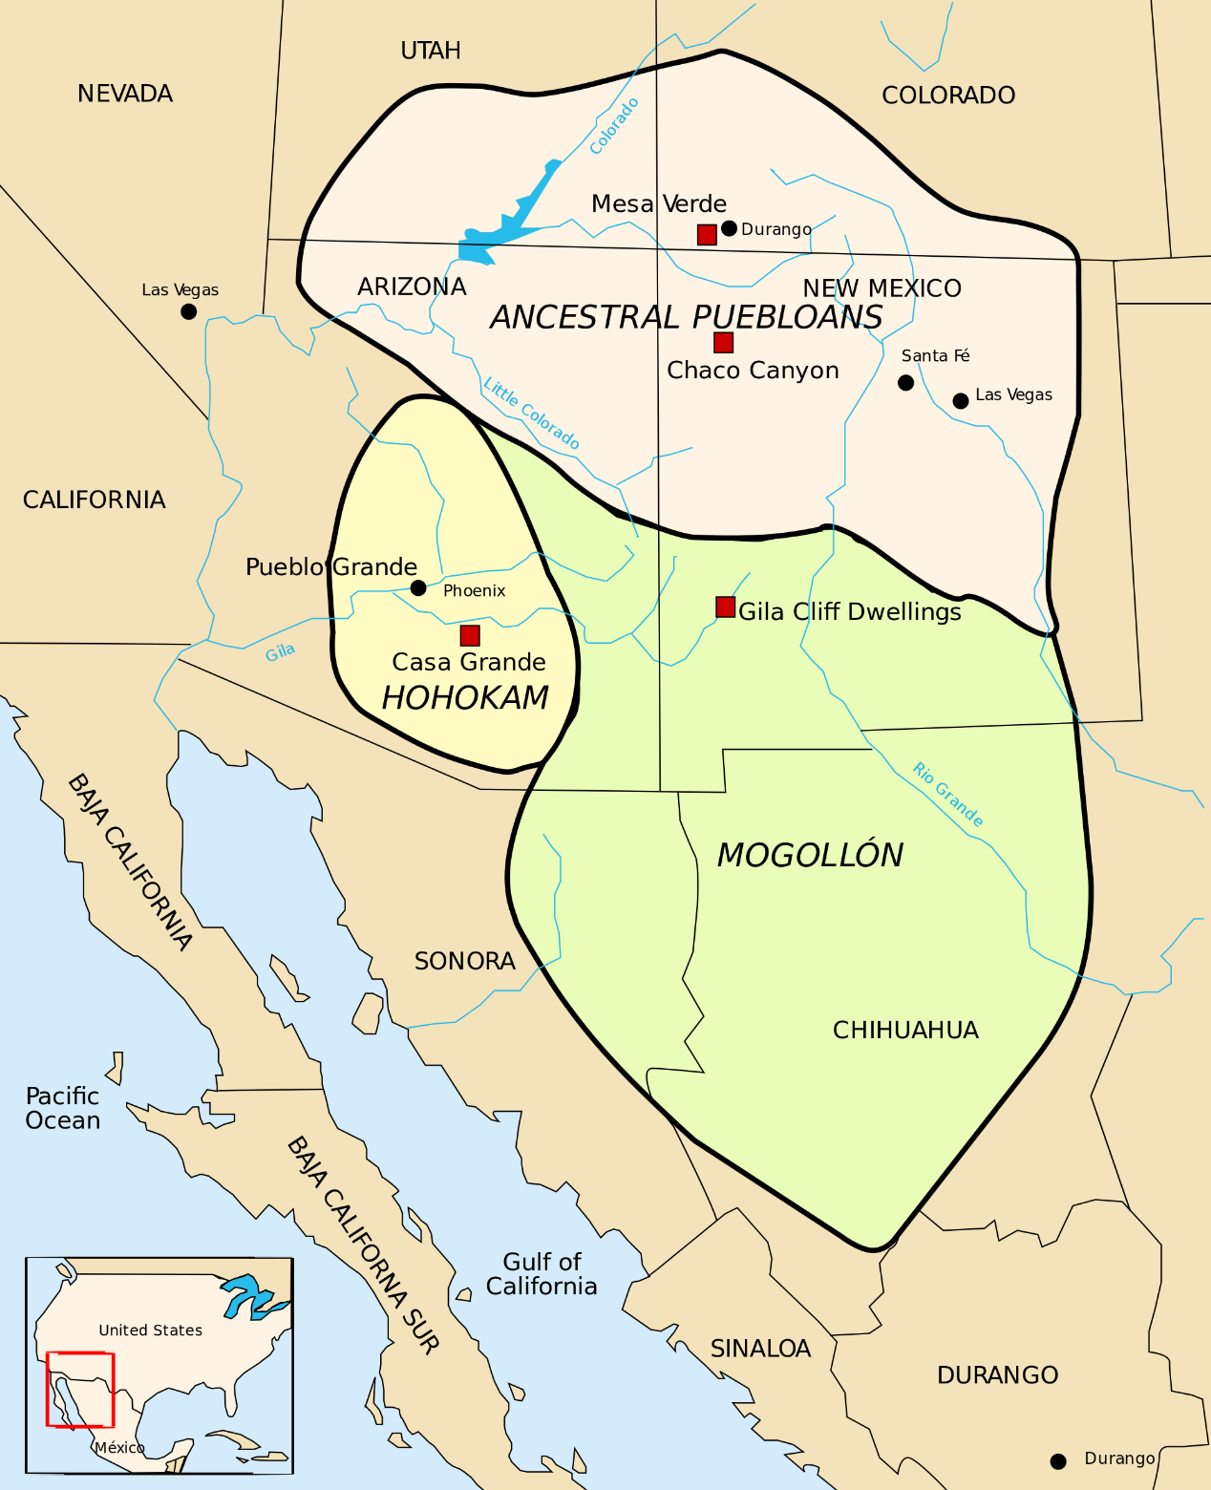remained distinct from the Pueblo people living in the region.

Map of territory showing areas where Ancestral Pueblos, Hohokams, and Mogollon peoples lived.

**Map of southwestern Ancestral Pueblo area.** Image source: [Wikimedia Commons](https://upload.wikimedia.org/wikipedia/commons/thumb/d/db/Map_Anasazi,_Hohokam_and_Mogollon_cultures-en.svg/487px-Map_Anasazi,_Hohokam_and_Mogollon_cultures-en.svg.png)

**Common food practices: introduction of agriculture**

Historians credit Anasazis, Mogollons, and Hohokams as the first farmers in America. **Corn**, the first crop the Ancestral Pueblos cultivated, permeates many creation stories of the Pueblo people. The Ancestral Pueblos regarded the harvest of corn not only as a nutritional necessity but as a spiritual gift. Although agriculture seemed to represent the society’s advancement, the Ancestral Pueblos had a much healthier diet when they hunted and gathered, as opposed to the limited diversity in a diet dominated by corn.

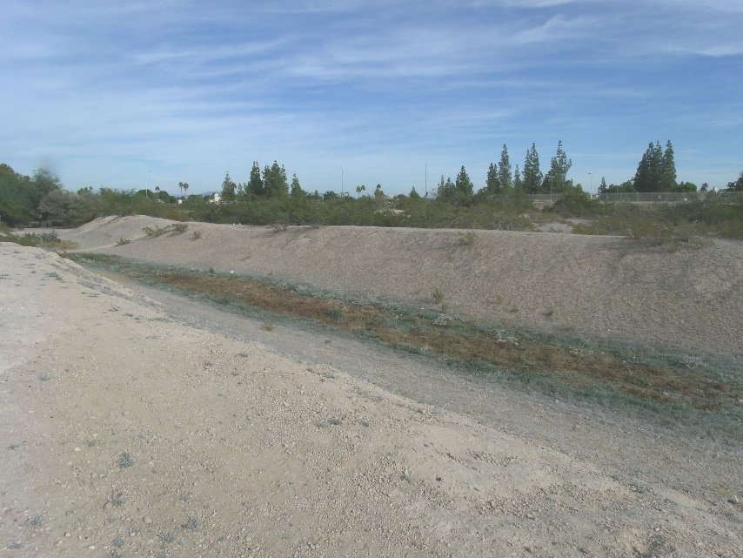In the arid climate of the Southwest, Ancestral Pueblos developed complex **irrigation systems**, which maintained crops even in the hot sun. By 800 CE, Hohokams had created one of the largest irrigation systems to date, stretching through most of what we call Arizona today. This new irrigation system allowed the Pueblos to begin planting beans and squash in addition to corn.

Photograph of a Hohokam canal today.

**An ancient Hohokam canal, used for irrigation.** Image credit: [Wikimedia Commons](https://commons.wikimedia.org/wiki/File:Mesa-Park_of_the_Canals-1875_Mormon_Canal.JPG)

These elaborate systems enabled agriculture to flourish, which allowed new forms of production and societal development. Women began to make ceramic pots to hold the surplus of corn, squash, and beans, and large vessels to grind the corn. They also wove baskets with which to collect the harvest.

Although agriculture boomed in the region, **Navajos** and **Apaches** arrived from the Pacific Northwest in about 1200 CE and retained the dominant food practice of their home region, hunting and gathering.

**Societal organization: villages and pueblos**

Agriculture dictated the way the Ancestral Pueblo people lived. With surplus food and stability, they became more sedentary, living in stone and adobe houses. Equivalent to massive present-day apartment complexes, these buildings had multiple stories, each with multiple rooms. The Ancestral Pueblos, regarded as highly developed for their time, tended to live in larger towns with thousands of people and [intricate dwellings](https://www.khanacademy.org/humanities/art-history/art-americas/early-cultures/ancestral-puebloan/a/mesa-verde-cliff-dwellings).

**Chaco Canyon**, a center for the Anasazi people, was a trade hub and home to over twelve thousand people. The Chacoans, a branch of the Anasazi people living in the canyon, created over four hundred miles of roads that connected the town to other villages in the region. The Chacoans mostly traded away turquoise, traveling west for seashells from California, south for exotic birds from Central America, and north for minerals and ores from the Rocky Mountains.

**Pueblo Bonito, a famous archaeological site, in Chaco Canyon.** Image credit: [Wikimedia Commons](https://commons.wikimedia.org/wiki/File:Chaco_Canyon_Pueblo_Bonito_Ruin.jpg)

Navajos and Apaches were more nomadic as they continued to hunt and gather. Since they were always on the move, their homes were much less permanent than pueblos. For instance, Navajos fashioned their iconic eastward-facing round houses, known A small hut in the desert
as **hogans**, out of materials like mud and bark.

**A traditional Navajo hogan.** [Photo](https://upload.wikimedia.org/wikipedia/commons/1/1b/Navajo_Hogan,_Monument_Valley.jpg) courtesy of Wikimedia Commons.

**Social and religious norms: the spirit of the crop**

These southwestern peoples believed that farming was a more reliable way to ensure their society’s sustenance than hunting and gathering. But that hypothesis proved false in the face of **natural disaster**. A persistent drought, lasting from about 1130-1180 CE, decimated Anasazis' crops, while a major flood in 1358 destroyed the Hohokam irrigation system.

These disasters led the Ancestral Pueblos to hold spiritual ceremonies, praying to their gods for a bountiful harvest and good weather. They would pray to natural entities, like plants and animals, for agricultural, hunting, and personal success. These religious ceremonies brought together lots of people to create larger religious communities than social units like the family.

The extended family lived and worked together, both women and men participating in the agricultural processes. Since the Pueblos did less hunting, men helped with farming. In addition to farm labor, women raised children and performed household tasks, while male heads of households would participate in an informal council to make community, or **band**, decisions.

**A kiva, shown above, was a room constructed for religious rituals, used by both Ancestral and modern Pueblos.** [Photo](https://upload.wikimedia.org/wikipedia/commons/6/65/Bandelier_Kiva.jpg) courtesy of Wikimedia Commons.

Ultimately, most of the Ancestral Pueblos fled the area, probably due to drought. The Spanish encountered a hodgepodge of remaining descendants of the Ancestral Pueblos in the mid-1550s, whom they named the Pueblos.

**What do you think?**

How did the introduction of agriculture affect the religious practices of the ancient southwestern Native Americans?

How did the Ancestral Pueblos urbanize the southwest region? How did that compare to the Native Americans in the northeast region?

Do you think the Ancestral Pueblos should have continued hunting and gathering for their main source of nourishment? Why or why not?

Source: Khan Academy